**Our Lady of the Lake Parish**

**The Stained Glass Windows**

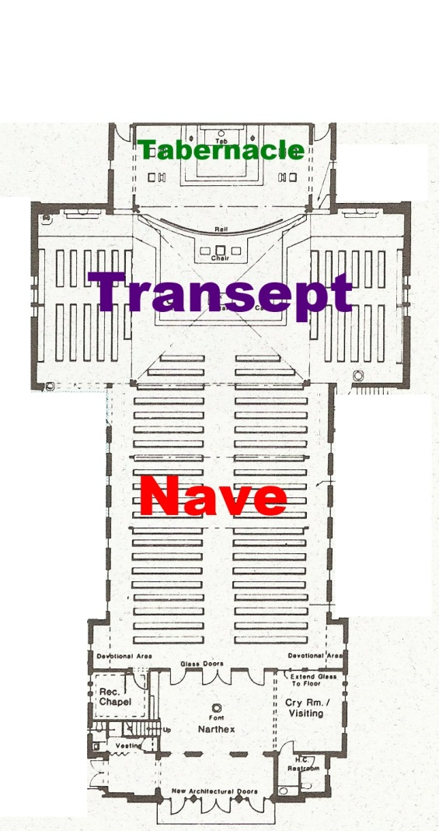

The Tabernacle Windows

The windows above show us 6 of the 7 Sacraments, with the Eucharist being in the Tabernacle, of course!

1. Baptism – A baptismal font.
2. Confirmation – A dove to signify the Holy Spirit.
3. Reconciliation – Two keys and a stole.
4. Matrimony – Two hands joining.
5. Holy Orders – A stole, the Eucharist, and the Missal.
6. Anointing of the Sick – Vessel containing the holy oil with the letters O.I. (Oleum Infirmorum).

Facing the Tabernacle, to the left is Saint Joseph and to the right is Saint Patrick.

The Transept Windows

The large window on the left (east) commemorates the Immaculate Conception of Mary.

Within that window, Adam and Eve are shown expelled from Eden. Next to them is an image of Mary who is standing on the head of Satan, depicted as a serpent.

Above the scene with Adam and Eve, the Annunciation is shown. So that Mary could become the Mother of God, she was born without sin.

The bottom of the window shows Pope Pius IX, who dogmatically defined the Immaculate Conception of Mary in 1854.

The Feast Day for the Immaculate Conception of Mary is December 8th.

The large window on the right (west) commemorates the Assumption of Mary.

Near the top of that window, Mary is crowned in Heaven and surrounded by angels.

Below that image is shown the Assumption of Mary being witnessed possibly by 4 of the Apostles, with Saint John being the one without a beard.

The bottom of the window shows Pope Pius XII, who declared the Assumption of Mary as a dogma in 1950.

The Feast Day of the Assumption is August 15th.

Salve Regina

Hail Holy Queen, Mother of Mercy, our life, our sweetness, and our hope! To thee do we cry, poor banished children of Eve; to thee do we send up our sighs mourning and weeping in this valley of tears. Turn then, most gracious advocate, thine eyes of mercy towards us; and after this our exile, show unto us the blessed fruit of thy womb, Jesus. O clement, O loving, O sweet Virgin Mary. Amen.

The Nave Windows

The windows on either side of the Nave show 14 of the 15 Mysteries (these were made before the Luminous Mysteries were added). Starting on the east wall, in the back, where the words Ave Maria Gratia Plena Dominus Tecum can be found (translates as “Hail Mary Full of Grace, the Lord is with Thee”). Then from there, go in a clockwise fashion down the east wall, then to the opposite west wall.

The Joyful Mysteries:

1. The Annunciation – The crown for Christ, the dove for the Holy Spirit, the lilies for Mary.
2. The Visitation – Lilies for Mary, the two roses may represent Mary and her cousin, Elizabeth.
3. The Nativity – Star of Bethlehem and a crib in a manger.
4. The Presentation of Jesus at the Temple – Two turtle doves, which is what poor Jewish families would sacrifice to redeem their first-born son. The sword recalls Simeon’s prophecy that a sword would pierce Mary’s heart.
5. The Finding of Jesus in the Temple – The scrolls with the Scriptures written on them.

The Sorrowful Mysteries:

1. The Agony in the Garden – Folded hands showing Jesus praying in the Garden of Gethsemane.
2. The Scourging at the Pillar – The pillar and whips.
3. The Crowning with Thorns – The word Rex (meaning “King”) is shown.
4. The Carrying of the Cross – The cross and the rope used to carry it, also showing the 30 pieces of silver on the bottom.
5. The Crucifixion – The 3 crosses, the 3 nails, and the spear.

The Glorious Mysteries:

1. The Resurrection – The Lamb of God holding a banner, signifying his triumph over death.
2. The Ascension of Our Lord – The chariot of fire recalls the Old Testament story of Elijah ascending into Heaven.
3. The Descent of the Holy Spirit – The dove representing the Holy Spirit that came down on the Apostles on Pentecost.
4. The Assumption of Mary – An anagram of M-A-R-I-A, along with 12 stars and the moon, symbols of Mary.

The 5th Glorious Mystery can be found above the choir loft, the crown at the center representing Mary, with moons and stars, as well as the Tower of David and Tree of Jesse which shows her belonging to the line of David.